Genomic DNA (gDNA) Extraction Protocols for Amplification of FPsc Marker Loci
Scott Woody, UW-Madison, Madison, WI
Published online to www.FPsc.wisc.edu Nov. 19, 2013

Two protocols are described. The first is quick and dirty but yields sufficient gDNA for multiple PCRs; however, the purity and stability of DNA preps are likely to be low and the extracts may not “keep” very well, even if frozen. The more elaborate miniprep protocol yields sufficient nucleic acid to visualize on an agarose gel and “keeps” well through multiple freeze-thaw cycles. My preference is for the latter (miniprep) protocol if time allows, since it affords the ability for students to visualize on a gel the products they have purified. In addition to helping students to form a more detailed mental picture of what is actually contained in the gDNA extract, gel inspection of extracts provides an additional opportunity for student “success” in the process of conducting PCR assays.
The selection of plant tissues that will be used in either protocol depends on the downstream steps intended to continue genetic analysis. Ideally one should harvest and extract gDNA from inflorescence tissue—the clutch of unopened flowers and shoot apical meristem at the growing apex of the plant. Alternatively, one can harvest leaf tissues, but gDNA yield per unit volume of tissue can differ considerably: the cells that comprise the inflorescence/apical meristem are very small and densely packed, whereas leaf cells are fully expanded and the tissue sample therefore contains a smaller number of nuclei/unit volume of tissue. However, “topping” the plant by harvesting apical inflorescence tissues can obviously complicate subsequent genetic analysis if one needs to collect seeds from the plant. A way out of this dilemma is to ensure that several early flowers have been hand-pollinated by your students (to ensure maximal fertility in those flowers); an actively flowering inflorescence would no longer be required for generation of progeny seeds.
Quick and dirty prep: Place a dime-sized piece of fresh leaf tissue in a 1.5 ml Eppendorf tube. Use a clean plastic pestle to grind tissue to a smooth pulp by twisting shaft of pestle between finger and thumb. Add 700 ul deionized water, grind some more if unpulped tissue remains and to rinse ground material from pestle. Spin ~2-3 minutes in microfuge to pellet debris, use 2-4 ul of supernatant in PCR (20 ul reaction volume).
Plant minipreps: This is an “old-shool” extraction protocol adapted from Dellaporta et al. (1983) Plant Mol. Biol. Reporter 1:19-21.
Grinding/extraction solution
 | Constituents: |  |  | To make 100 ml:
 | 100 mM Tris-HCl (pH7.9) |  |  | 10 ml 1M Tris-HCl (pH 7.9)
 | 50 mM Na₂EDTA (pH 8.0) |  |  | 5 ml 0.5 M Na₂EDTA (pH 8.0)
 | 0.5 M NaCl |  |  | 10 ml 5 M NaCl
 |  |  |  | distilled H₂O to 100 ml
10% SDS |  |  |  | 10 gm Sodium dodecadyl sulfate
 |  |  |  | Distilled H₂O to 100 ml
5 M Potassium acetate (KAc) |  |  |  | 49 gm KAc
 |  |  |  | Distilled H₂0 to 100 ml
Isopropanol
70% ethanol
95% ethanol
TE | 0.1 M Tris HCl (pH 7.9) |  |  | 10 ml 1M Tris-HCl (pH 7.9)
 | 1 mM Na₂EDTA (pH 8.0) |  |  | 0.2 ml 0.5 M Na₂EDTA
 |  |  |  | Distilled H₂0 to 100 ml
0.5 M HCl (destroys purine bases in DNA/RNA, used to decontaminate pestles)
 |  |  |  | 95 ml H₂O
 |  |  |  | 5 ml concentrated HCl
 | Note: Do as you oughta, add acid to wata'

- Prepare all solutions in advance, chill 70% ethanol to at least refrigerator temp.
- Harvest tissue (~100 ul total volume taken from inflorescence tissue; an equivalent volume of leaf material may suffice, but we can’t vouch for it) into 1.5 ml eppendorf tubes; store samples on ice.
- Use plastic pestle to grind tissue to a slurry
- Add 300 ul of extraction buffer and grind some more to disrupt any remaining clumps of tissue
- Add 50 ul of 10% SDS, mix gently but thoroughly by inversion (SDS disrupts lipid bilayer of cell walls)
- Place samples in 65 degr heating block or water bath for 10 minutes (further weakens/destroys lipid membranes and partially denatures proteins)
- Add 70 ul 5 M KAc, mix thoroughly by inversion and then keep on ice 5 minutes; spin at top speed in microfuge to pellet debris
- Use a pipette to gently withdraw supernatant from pelleted cell debris. Expect/aim for total volume of ~250 ul. Transfer to fresh 1.5 ml eppendorf tube
- Add 150 ul (or 0.6 volumes) of isopropanol (IpOH), mix gently but thoroughly by repeated inversion. Hold at room temp 5 minutes.
- Spin samples in microfuge 1-2 min at top speed (~13k rpm). Remove supernatant by using a micropipette, being careful not to dislodge the white pellet containing gDNA
- Reduce amounts of co-precipitated salts by washing the pellet using ice-cold 70% EtOH-- ~200 ul is enough, be sure to flick the tube enough to dislodge/disrupt the pellet
- Spin 1-2 min in microfuge, pull-off 70% EtOH and replace with ~equal volume of cold 95% EtOH; spin 1-2 minutes and remove supernatant. (The idea here is that, in the previous step, although 70% EtOH contains 30% H₂O, the [EtOH] is sufficient to keep the gDNA in an insoluble state but the H₂O allows residual salts to go into solution. The final 95% EtOH wash may do a little of the same, but it is intended primarily to leave a volatile material that will readily dissipate on exposure to air.
- Allow tubes to sit with caps open at room temp and then resuspend DNA pellets in 100 ul TE. Flick tubes repeatedly until pellets are no longer observable. Store gDNA extracts on ice. Nucleic acids (high molecular weight genomic DNA, ribosomal RNAs, mRNAs and gDNA degredation products) can be visualized by combining 5-10 ul of the prep with the gel loading buffer of your choice and fractionating samples on a 1% agarose gel + ethidium bromide). For PCR, dilute aliquots of the gDNA extract 1:10 and use 4 ul in PCR (20 ul total reaction volume). DNA extracts should be stored at -20 degr. C.
Implementation of the miniprep protocol: The following is a narrative written to a collaborating teacher while I was in the course of testing/optimizing the miniprep protocol and is presented “as is” in hopes that it may be of use to others.
Now, onto the genomic DNA purification protocol. I’m happy to hear that it worked for you, though just a bit surprised, since I botched the recipe. I learned this over the last couple of days as I worked through the protocol myself. I had used a similar protocol in the past but it had been a while and I thought that working through it as I imagined a HS teacher might do would be a good idea—and it certainly was. It’s one thing to work comfortably in our well-stocked lab with the stock solutions on the shelf and a chemical closet at pH meter at the ready, but I (belatedly) realized that that is not a world most teachers inhabit. So here’s what I did:
I prepared the extraction buffer as in the recipe I sent to you. Everything went well until I added the SDS, at which point a flocculent precipitate formed—that’s a Good Thing, but not at the point in the protocol where you are merely preparing reagents (we’ll get back to that later). I made the 5 M potassium acetate (KAc) solution—not too painful as it is very hygroscopic but still, 5 M salt is a lot. I made the 70% and 95% EtOH stocks and put them on ice; I made the TE using a 1 M Tris solution buffered to pH 7.9 and 0.5 M EDTA (pH 8.0) that I had on hand. I harvested inflorescence tissue (a cluster of unopened flower buds) from two plants into 1.5 ml eppendorf tubes. I didn’t measure precisely, but I would guess that if spun in a centrifuge to pellet/compact the tissues, it would have come to ~100 ul (0.1 cm³ total volume. I used a plastic pestle to grind the tissue into a green globby mush, then added 300 ul of extraction buffer (- SDS) and chased the remaining clumps to mash them with the pestle and then added 50 ul of 10% SDS (thus yielding about the 1.5% final SDS concentration specified in the recipe. No flocculation at that point, BTW, although the suspensions became noticeably more viscous.) I put the tubes in a 65 degr heating block for 10 minutes and then added 70 ul of 5 M KAc, at which point the suspensions turned quite lumpy (they flocculated) as proteins and other debris were “salted-out” in biochem lingo.
I mixed the tubes by inverting repeatedly for about 1 minute and then put them on ice for 5 min. I spun the tubes for 2 min at top speed (13.2k rpm) in a microfuge and transferred the supernatants to fresh tubes using a P200 set at 150 ul and taking two dips (avoid the flocculent gunk at all costs) to recover ~250 ul total volume. I added 0.6 volumes (150 ul) of isopropanol (IpOH) and looked for localized nucleic acid precipitation at the interface of alcohol/aqueous phases but didn’t see it. I mixed gently by inversion until the striations initially evident in the solution had disappeared. After 5 min at room temp, nucleic acids were pelleted by centrifugation at top speed for 2 minutes; small white pellets were visible at the bottom of the tubes. I pulled-off the supernatant using a P200 and added ~200 ul ice-cold 70% ethanol (EtOH). The pellets, as expected, did not dissolve into solution but I flicked the tubes hard enough to make sure that they were dislodged from the wall of the tubes in order to grant the 70% access to the constituents that are presumably going into solution (I have little idea what those might be, but guess that some residual salts from the extraction buffer come out). I repeated with a 95% EtOH wash and, as with all similar manipulations, used a P200 to pull-off the supernatant as best as possible; if you try to pour it out either the pellet will dislodge and go down the drain or you’ll end up with fluid coating the walls of the tube, thus extending later steps. Finally, I left the tubes open on the bench for ~5 minutes to allow residual EtOH to dissipate (avoiding the temptation to put the rack in the air flow of our fume hood which would accelerate the process but is unavailable to most teachers). I added 100 ul of TE to resuspend the pellets and watched them dance (that’s really cool—for whatever reason, relatively pure nucleic acid pellets dissolve somewhat explosively [on a small scale] when exposed to aqueous solution—the pellet dances across the meniscus from side to side until it is dissolved; look for it).
In order to see if I had actually recovered enough gDNA to see on a gel and to verify that the DNA preps are suitable for use in PCRs, I took each of the two preps through a 2-fold dilution series using TE. Aliquots of the dilution series were combined with loading buffer and run on a 1% agarose gel containing ethidium bromide. An equal volume (4 ul) of each diluted sample was used as template DNA in PCRs. Amplification from diluted samples of gDNA prep 1 were primed with oligos (RP325/326) that distinguish among possible genotypes at a polymorphic (FPsc vs R500) site located ~16 cM from the ale locus; PCRs using similarly diluted prep 2 gDNAs were primed with oligos (RP565/566) that amplify a marker located ~3 cM from the ale locus. The results of gel analysis of gDNA yield and PCRs using the 2-fold dilution series are shown below.
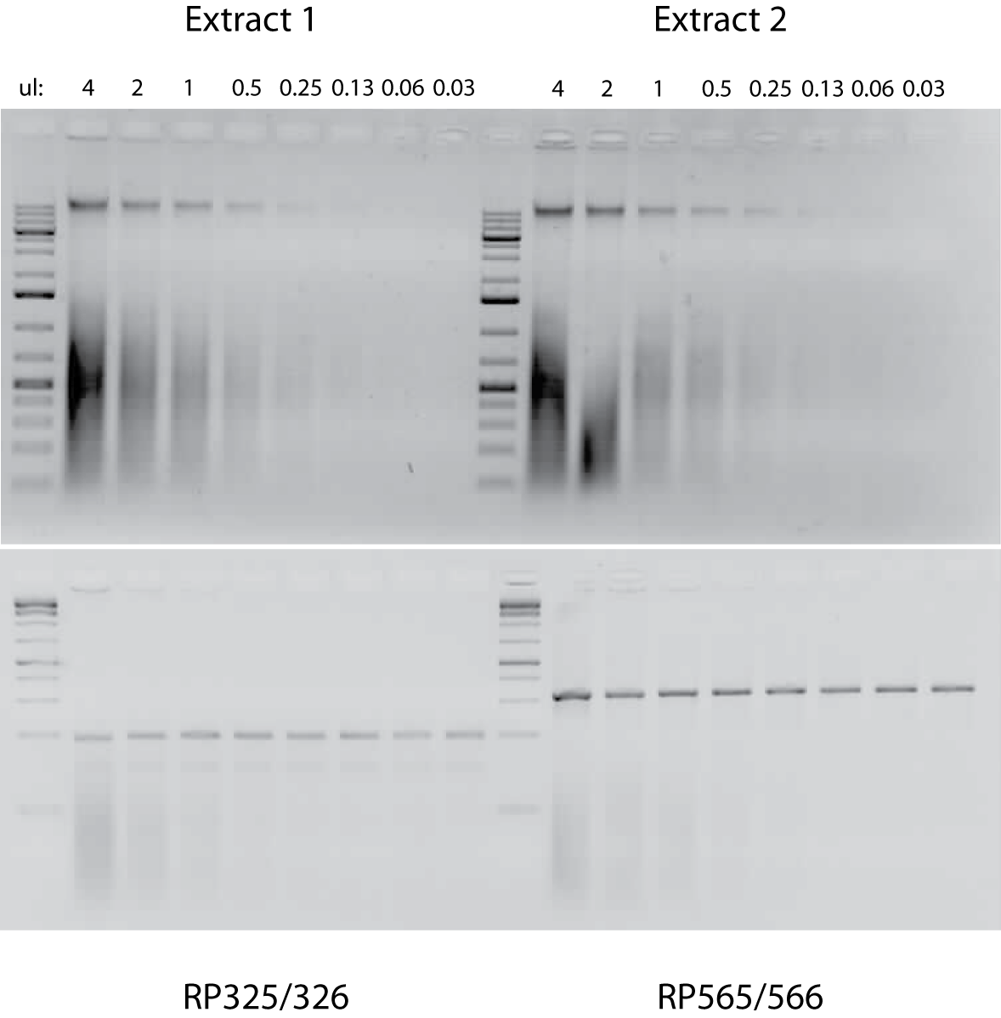
Upper panel: gDNAs extracted from two inflorescence tissue samples taken from B. rapa var. FPsc and serially diluted in 1/2x steps. Amounts equal to those shown in the upper panel were used as templates in the corresponding PCR amplifications, whose products are shown in the bottom panel.

So the good news is that (a) the gDNA extraction protocol works, and it doesn’t involve any hazardous materials (e.g., chloroform or phenol); and (b) it works pretty darn well! While visualization of the gDNA bands (uppermost in the top panel, above what I assume are RNA blobs) are extinguished through the dilution series, there is little sign that the yield in PCR is at all diminished even with ~100-fold dilution of the 4 ul (of 100 ul, total) of gDNA sample extracted from plant tissues. In principle, then, the protocol could yield gDNA preps sufficient to provide template for at least 2,500 PCRs.
I’m good with that, and I think it could be done within a 50 minute class period, provided that everything goes well. Of course that will probably not be the case, so it’s useful to think of stopping points in the event that the purification protocol needs to extend beyond a single class period. The most vulnerable periods (with regard to gDNA integrity and yield) are during the initial lysis steps as nucleases are on the loose, so you need to get at least to the first (IpOH) precipitation step before taking a break. However, and for reasons that I don’t actually understand, IpOH precipitations are typically done at room temp and I vaguely recall a suggestion that salts from the extraction buffer will precipitate if the extracts are chilled, so it’s probably best to get at least to the 70% EtOH wash step, at which point I think the samples could be held in a freezer indefinitely; the succeeding session could start by pelleting the samples, etc.
Good luck and let me know how it goes for your students.

